NATIONAL ACCOUNTS

Procedures within Support Center
National Accounts are generated by:
- Direct leads to National Account Department in Global Support Center
- Leads generated by the Field Sales Representatives in all offices

When a National Account is contracted, procedures are generally different because the National Account Customer has requested them. Direct Billing, Collections and Account Contact Reporting are centrally done at the Global Support Center.

The payment for services is then passed directly to the offices that are cleaning these accounts in order to pay the Franchise Owners.

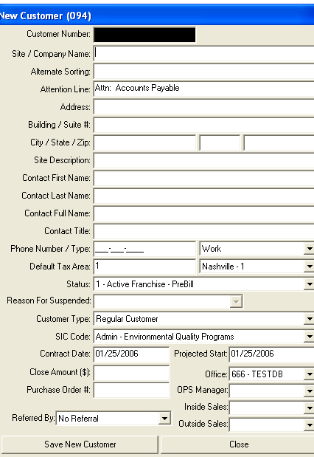
The paperwork still must be documented and completed by the Sales and Operations departments within the office in order to track services and Business Owed.

Sales are primarily responsible for:
- Work Schedule
- Account Start Form

Operations are primarily responsible for:
- Key Pick-up/Acceptance Form
- Query and Assignment of a Franchise Owner
- Signature of Acceptance
- Data Entry Information

Once the Franchise Owner agrees to the terms and work schedule for this particular account all information must then be entered into the computer. It is very important this is completed in a timely manner, in order to:
- Bill the Customer
- Pay the Franchise Owner

From the information provided to you by the National Account Department, your sales and operations staff, you can enter all pertinent information about this new customer.

National Account Billing Guidelines
Each time there is a New Account; that is considered National and billed through the Global Support Center the following steps must be done to ensure that the National Account Billing set up is correct.

These instructions pertain to all accounts that have a Customer Request “One Invoice Summary”.

Entering a Close
Step 1-If you are notified that this Customer requires 1 invoice:
✓National Account Customers must be set up under 1 Customer Number.
Each cleaning site then is set up in the Modify Site screen with address, contact and phone information for each location that is listed. This will enable you to create 1 Summary Invoice listing all locations and amount of each.

Refer to the listing of accounts and the National CIS ID number must be entered into your office CIS system.
- Go to Customer
- Click Add New
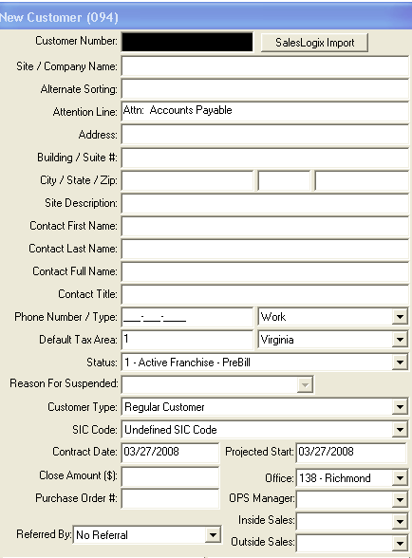
- Enter New Customer information with Coverall North America as Billing Address.

Example: Ferguson
The Customer Name would be: Coverall North America-Ferguson
Address: 5201 Congress Ave Ste # 275
Boca Raton, FL 33487
Description field: Billing Location
Customer Type, select from list: National

Complete all fields,

Operations personnel, use pull down list and select person who will manage this account
- Inside Sales, use pull down list and select personnel who sold this account, this will be reflected on all reporting documentation for commission purposes.
- Outside Sales, use pull down list and select personnel who sold this account, this will be reflected on all reporting documentation for commission purposes.

Click Save
- Once you are again at the Profile screen,
- Click Edit (top right portion of screen)
- Enter National ID in field,
Refer to National Account Listing and Change National ID, by ENTERING THE CORRECT 10 CHARACTER INFORMATION
EXAMPLE: 00FERGUSON (10 CHARACTERS IN TOTAL), USE CAPITAL LETTERS ONLY
⬅10-character number must go here –CIS National Account ID

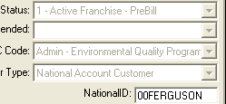
- Click Save when completed and Profile will now have updated National ID information

Step 2-Modify the site
To set up multiple locations service sites you must modify the site of the Customer Profile
- Click on the Modify Site Button, on bottom of Customer profile screen
- Refer to the listing of accounts and the Location ID
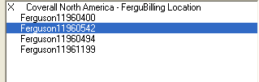
- If there are multiple locations, each location must have all details that National Account list provides
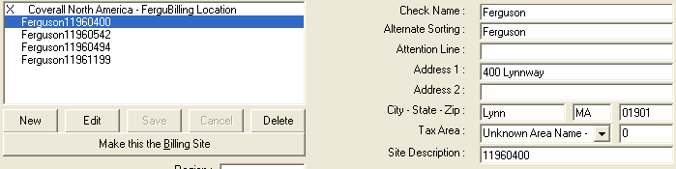
- Add the New service sites to the screen by clicking on New , top left side of screen
- The right side of the screen will be enabled for entry of information
- Enter Location ID
THE ON SCREEN INFORMATION MUST BE THE SAME AS THE ACCOUNT LIST RECEIVED. NOTHING ELSE SHOULD BE IN THE LOCATION ID

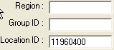
Complete all fields with information received

- Click on Save, after each one is completed

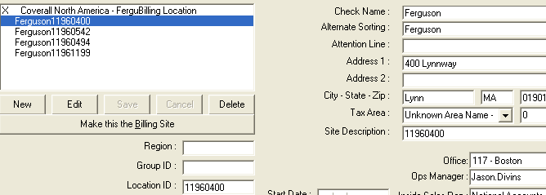
Customer information must be completed

⬅Locations ID must go in field -Location ID-do not enter a # sign or city name.
ID MUST BE A NUMBER

Step 3- Entering the Start and Billing for All Sites
Once all Site Address information has been complete for all Sites, then you need to go to the Services Tab and Set up Each Site RS and Franchise Owner or Sub Contractor.

When a National Type Account service billing is set up, automatically this type of account will be set to National Billing Cycle.
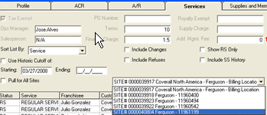
- By using the pull down listing, you will see each site location listed.
- To work with one site, choose the site from the list
- Uncheck  Pull for all sites
- Click on Modify Button and Services Screen will open for entry of information
- Enter all information, using the correct Service Code,
- Refer to document from National Accounts and enter Customer Amount and Payable amount to Franchise Owner

Operations personnel, use pull down list and select person who will manage this account
- Inside Sales, use pull down list and select personnel who sold this account, this will be reflected on all reporting documentation for commission purposes.
- Outside Sales, use pull down list and select personnel who sold this account, this will be reflected on all reporting documentation for commission purposes.
- Once completed, Click Save.
- You will then return to the Service Screen and using the pull down listing select the next cleaning site location
- Click Modify to add service information
- Each Site must have Services set up according to document received from the National Account Department

National Account changes to National Local
Sometimes an account that was considered a National Type account, billed through GSC changes to a National Local account.

The National Account may decrease locations and request to be billed through the local Regional Support Center.

In this case the National Account must be terminated along with all locations that are requesting this change.

Because the National Account Billing department manages the A/R of a National Account, the change must be done so the local Regional Support Center can set up this account now as a National Local or Regular account.

The National Account Department at GSC will notify you when such an occurrence happens.

